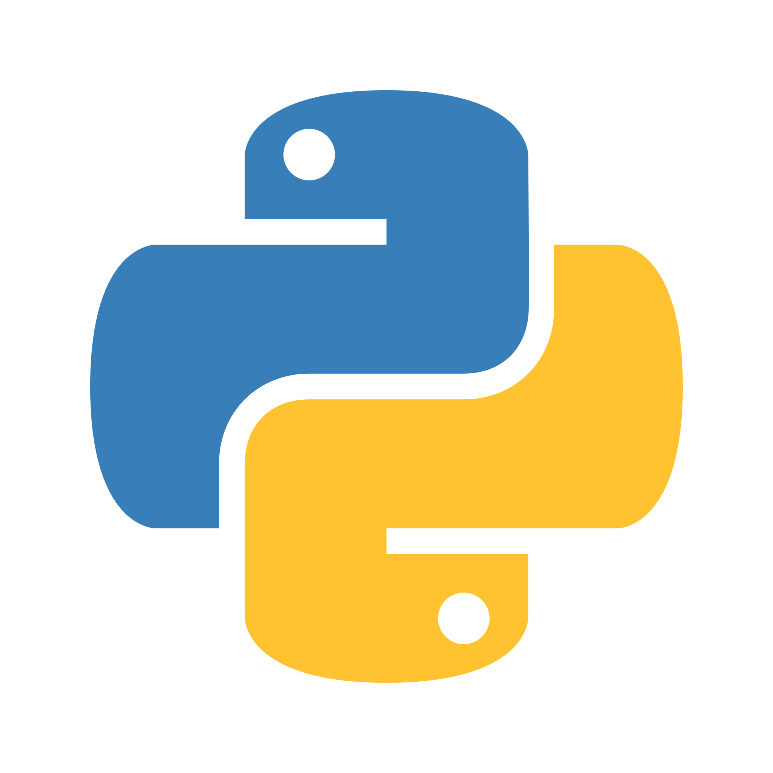**Python Resources**

# Working With Python

The good thing about Python is you can basically run it anywhere, as long as you have Python installed. Easy peasy! However, you might want to use an IDE (Integrated Development Environment) to work with Python. You’ll hopefully enjoy working with Python a bit more using a good IDE, as it’ll help you debug, fix, test and run your code.

[Don’t forget to install Python 3.7 or higher!](https://www.python.org/downloads/)

There’s no set rule over what you should use, but I’d recommend checking these out:

* [PyCharm Community Edition -](https://www.jetbrains.com/pycharm/download/#section=windows) As long as you use the community edition, this is free to use (and you probably won’t need to use the pro features!) Definitely my top pick for running anything to do with Python.
* [Visual Studio Code (VSCode) -](https://code.visualstudio.com/) Also free to use, so super handy. This IDE is made to support nearly every programming language under the sun, so there’s a bit of extra setup and configuration required to get it to run Python nicely.
* [JupyterLab -](https://jupyter.org/install) This final option is definitely for tech-savvy people. It doubles up as a notebook that you can run code snippets in, so it’s quite handy for revision. It does have a slightly more complicated installation process, so I wouldn’t recommend it unless you’re comfortable running all the steps.

# Learning Python

Okay, you’ve got your shiny setup going… Now you actually have to get some Python coding going! There are plenty of resources to help you learn Python, or to have as a reference while you’re programming. Obviously you can’t use these in an exam, but they’re useful for getting to grips with the syntax and also just experimenting with small snippets of code.

* [W3 Schools -](https://www.w3schools.com/python/) I have been using W3 schools for goodness knows how long because it’s just that good. The examples are simple and well explained, and the ‘Try it Yourself’ functions mean that you can pick apart small blocks of code to figure out how they work.
* [Learn Python -](https://www.learnpython.org/) This is a great way to learn Python and get a better explanation of the concepts. You don’t need to worry about the Data Science or Advanced tutorials, you’ll only need to know the basics. It’s a good site that explains *why* Python lays things out the way it does.
* [Python Land -](https://python.land/python-tutorial) Only parts 1-4 of the tutorial are applicable for beginners, but it still explains things. A lot more interactive and takes you through Python as if you’ve never looked at it before.